\begin{abstract}

In this paper, we report on the study of Abelian statistics through Fabry-Perot interferometry. We confirm the Abelian anyonic braiding statistics in the $\nu = 7/3$ FQH state through detection of the predicted statistical phase angle of $2\pi/3$, consistent with a change of the anyonic particle number by one.

\end{abstract}

In two spatial dimensions particles are not limited to being bosons or fermions as they are in three dimensions, but can be particles known as anyons [1-3] which obey exotic exchange statistics. These anyons can be braided around one another, independent of specific path chosen, altering the quantum mechanical state of the system. Anyons can be classified into two types, Abelian and non-Abelian, both of which are predicted [2-5] to be realized in certain fractional quantum Hall (FQH) systems. Currently, two dimensional electronic systems at low temperatures and high magnetic fields are the most robust platforms for exhibiting these FQH states. **[Needs more motivation? mention experimental detection of fractional statistics and quantum computation?]**

FQH states are labeled by their filling fraction $\nu$, a dimensionless ratio of electron density to magnetic flux. FQH states at $\nu = \frac{1}{m}$, with $m$ odd, are an incompressible fluid with anyonic quasiparticle excitations exhibiting fractional charge $q = \frac{e}{m}$ and fractional statistical phase $\theta = \frac{\pi}{m}$[13-16]. As pairs of filled Landau levels are inert, a FQH state at $\nu = \frac{7}{3}$ will behave functionally similar to $\nu=\frac{1}{3}$.

Exchange statistics of anyonic quasiparticles may be detected through quantum interferometry experiments, where the quasiparticles braid around a group of localized quasiparticles at the center of an interferometer [9, 12, 27]. In a quantum Hall Fabry-Perot interferometer, interference trajectories are realized through coherent transport along edge channels and tunneling across a pair of split-gated constrictions, which act as beam splitters. For $\nu = \frac{7}{3}$, the diagonal resistance through the device varies as

\begin{equation}

\delta R_D \propto \Re{R_{q}e^{i\phi}},

\end{equation}

where $R_{q}$ is the tunneling amplitude for the Abelian quasiparticles of charge $q%, and $\phi$ is the interference phase which is a sum of the Aharonov-Bohm phase due to flux enclosed by the edge and the statistical phase $2\theta$, as a braid around the device is equivalent to two exchanges, for each quasiparticle encircled by the edge. For $\nu=\frac{7}{3}$ the measurement should detect phase-slip events of $\phi = \frac{-2\pi}{3}$ corresponding to the excitation of an Abelian quasihole, experimentally $\phi=\frac{4\phi}{3}. If there are no quasiparticle interference effects only Aharonov-Bohm oscillations will be present.

Our Fabry-Perot interferometer was fabricated from a high mobility, symmetrically doped GaAs/AlGaAs quantum well with an etched diameter of 1.2 $\mu$m and a width between the two constrictions of 400 nm. An SEM image of the interferometer is shown in Fig. 1a. The sample was mounted on a dilution refrigerator and cooled to 10 mK. Diagonal resistance, which isolates the edge channel [QT], R$_D$, is measured as the voltage bias on the plunger gate, V$_P$, is swept at a steady rate while the magnetic field, B, is held fixed. The bias voltage changes the interferometer area resulting in interference oscillations and excitation of quasiparticles. Fabry-Perot interferometers function in two regimes: Aharonov-Bohm (AB) where the bulk and edge are decoupled, and Coulomb-Dominated (CD) where they are coupled [4-6BEC]. We believe our device primarily operates in the CD regime [27].

Fig. 2 illustrates interference data from an interferometer tuned to $\nu = \frac{7}{3}$. The color plot in (a) demonstrates a region of magnetic fields where only trivial Aharanov-Bohm oscillations are visible, followed by an activation at $B=5.744$ T of positive slopes which is characteristic of Abelian quasiparticle interference in the CD regime [27]. **[Maybe skip the color map]** Rapid phase slips with $\delta\phi = \frac{4\pi}{3}$, are visible in (b), as well as corresponding fits, for various magnetic field values, reflecting the excitation of an anyonic quasiparticle. In (c) a histogram is generated by counting each phase slip as an event, with a median value of $1.325$. **[**fitting a Gaussian with a mean of mean of 1.310 and a standard deviation of 0.120**[Maybe skip gaussian fit and use median? No reason to believe the data should be gaussian distributed]]**. As these quasiparticles are holes, we expect to see a $\delta\phi = -\frac{2\pi}{3}$ or experimentally $\delta\phi = {4\pi}{3}, which verifies that our experiment coincides with the theory. It is important to note that one data sweep can dominate the histogram, as there can be many phase slip events for one fit.

In order to preserve the unbiased nature of our analysis, we developed an algorithm to determine and count the phase slips events. The data is smoothed with a local, spanning less than 1% of the data, linear Savitzky Golay filter to remove any noisy points. At even increments throughout the data a pair of counter propagating sine waves are fit, holding all parameters save the phase constant between the waves. The fits with non-trivial phase difference are collected and then examined as the functions are non-convex, and even with appropriate initialization, can fail to properly fit the data. Fits with the lowest squared loss are kept for fits spanning a similar voltage range in a single event. A slip event is defined as signal fit by one sine wave, with a distance threshold of 20 Ohms, for at least 0.045 mV, which within 0.2 mV is fit by the same sine wave with a phase offset for the same appropriate time. The phase offset is recorded as a phase slip event. **[Maybe mention the counting scheme before the data?]**

In summary, we have detected the exchange statistics of Abelian anyons in the $\nu=\frac{7}{3}$ state. Our data demonstrates sinusoidal interfere behavior with discrete changes in phase associated with the presence of a fractionally charged quasiparticle. Interference is a powerful technique for probing anyonic properties of FQH states, and with time the fidelity of detection will improve and lead to the realization of a topological quantum computer.

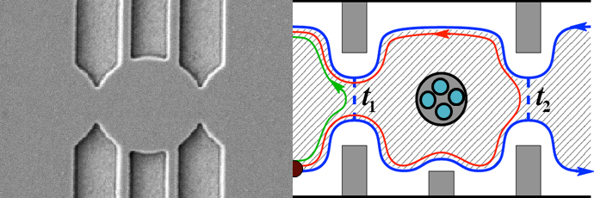Fig 1:

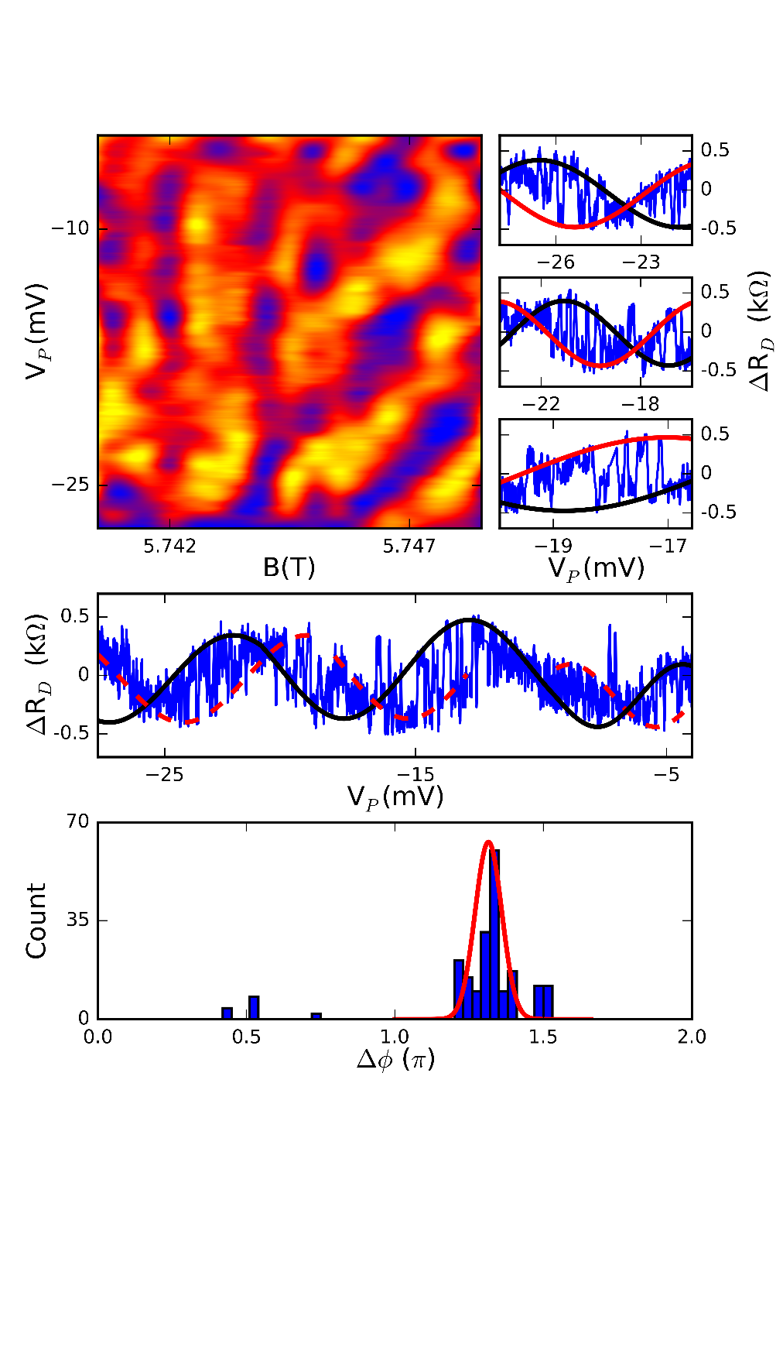Fig 2: